**Hibernate object states-**

It is called as life cycle of POJO class objects.

There are three types of objects in the hibernate as-

Transient state

Persistent state

Detached state

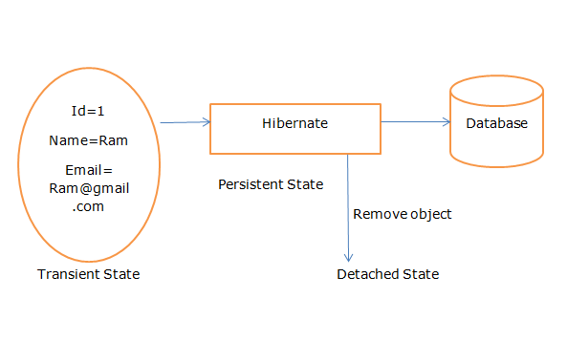

Transient State-

Simple object or plain object or before going too attached with hibernate called as transient state.

Persistent State-

A plain java old object attached with hibernates called as persistent state.

Detached State-

A process of deleting object from hibernates called as detached state.

**How to write the POJO class?**

POJO class needs to contain the required number of property which are storing into table.

POJO class in which default constructor is mandatory.

For every property, setter and getter need to be provided.

Setter and getter access should be public.

Note- there are several names for POJO class such as formbean, valueobject, etc

Program-

**Student.Java**

**package** com.test;

**import** javax.persistence.Entity;

**import** javax.persistence.Id;

@Entity

**public** **class** Student {

@Id

**private** **int** id;

**private** String name;

**private** String city;

**private** String mobile;

**public** **int** getId() {

**return** id;

}

**public** **void** setId(**int** id) {

**this**.id = id;

}

**public** String getName() {

**return** name;

}

**public** **void** setName(String name) {

**this**.name = name;

}

**public** String getCity() {

**return** city;

}

**public** **void** setCity(String city) {

**this**.city = city;

}

**public** String getMobile() {

**return** mobile;

}

**public** **void** setMobile(String mobile) {

**this**.mobile = mobile;

}

}

**Test.java**

**package** com.test;

**import** org.hibernate.Session;

**import** org.hibernate.SessionFactory;

**import** org.hibernate.cfg.Configuration;

**public** **class** Test {

**public** **static** **void** main(String[] args) {

Student student= **new** Student();

student.setName("Ram");

student.setCity("Pune");

student.setMobile("8888978585");

//student object is transient

Configuration configuration= **new** Configuration();

configuration.configure("hibernate.cfg.xml");

SessionFactory sessionFactory=configuration.~~buildSessionFactory~~();

Session session=sessionFactory.openSession();

session.save(student);

//student object is persistent

session.beginTransaction().commit();

session.evict(student);

/*student object is detached or student object is removed from

*persistent state.

* */

}

}